Dear Families,

I am delighted that your child is in my class this year. We can both look forward to many exciting and rewarding experiences. Life-long success depends on self-discipline. In our class, we will be using a behavior management system that affords every student the opportunity to manage his/her own behavior. We will be using a clip system.

Your child will clip up or down depending on his/her behavior. Please review your child’s behavior tracker each night and initial the box. Encourage your child to do his/her best each day.

Super Student | Great Job | Good Choices | Ready to Learn | Warning | Teacher’s Choice | Parent Contact
Purple | Pink | Blue | Green  (Everyone begins here each day) | Yellow | Orange | Red
Yours in Learning,
Mrs. Wilcox
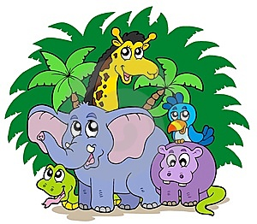

Dear Families,

I am delighted that your child is in my class this year. We can both look forward to many exciting and rewarding experiences. Life-long success depends on self-discipline. In our class, we will be using a behavior management system that affords every student the opportunity to manage his/her own behavior. We will be using a clip system.

Your child will clip up or down depending on his/her behavior. Each color/spot is worth different pebble amounts. Your child will have the chance to “cash in” his/her tickets for prizes/award coupons at the end of each week. Please review your child’s behavior tracker each night and initial the box. Encourage your child to do his/her best each day.

Super Student | Great Job | Good Choices | Ready to Learn | Warning | Teacher’s Choice | Parent Contact
Purple  Points 4 | Pink  Points 3 | Blue  Points 2 | Green  (Everyone begins here each day)  Points 1 | Yellow | Orange | Red
Yours in Learning, Mrs. Wilcox

